Assessment of Students in Online Industrial Practice Activities Using Machine Learning Based on Mobile Application

Sunarti^{(1),} Hie Ling Ting⁽²⁾, Tiksno Widyatmoko⁽³⁾, Herri Akhmad Bukhori⁽⁴⁾

Universitas Negeri Malang
Jl. Semarang No.5, Sumbersari, Malang, Jawa Timur – Indonesia
Universiti Teknologi Mara, Sarawak Branch, Malaysia

Email: sunarti.fs@um.ac.id, ² tinghieling@uitm.edu.my; ³tiksno.widyatmoko.fs@um.ac.id; ⁴herri.akhmad.fs@um.ac.id

Abstract: All of the learning in the pandemic era uses online learning including practical in the industry that should do all of the students to apply their knowledge. The practical industry online is very difficult to assement students that the assessment is given from both company and the university. Companies have many parameters to assessment and each company has different parameters. This study uses 14 parameters that are generally used in assessment for practical students and the university side using 10 parameters. The problem is that every parameter has a different weight than it makes it confusing to give marks with manual assessment. This research uses machine learning to fix this problem based on mobile applications for the user interfaces. The result of testing this application had an average accuracy for assessment students based on parameters of companies and universities that is 83,3%.
Available Online
http://www.jurnal.unublitar.ac.id/index.php/briliant

History of Article
Received on August 2021
Accepted on November 2021
Published on November 2021
Hal. 764-774

Keywords:
assessment, mobile application, machine learning
DOI:
http://dx.doi.org/10.28926/briliant.v6i4.757

INTRODUCTION
During the pandemic, all subjects in the university use online that one of the subjects is practical in industries. The online practical industry is very struggling for students, companies, and universities (Darmawan, 2020). One of the problems is how to assess students online that students do online. Companies usually assess students with their parameters, so do with the university. One of the big problems is that students did not exist on the site of companies because they have done it online. Companies usually assessment student as their employee, so it does not fair for students because they are not an employee (Elzainy, 2020). To fix that problem, companies and universities need an application that can help them to assess with accuracy based on the ability of students(Shakarami,2020). Clearly, to solve the problem assessments in online learning are needed an application that is embedded in online learning to help companies, universities, and supervisors to evaluate and assess students easier.
After 1 year of pandemic, there was much research about assessment for students. The assessment uses an online learning application such Moodle that assessment is manual, it just a user interface and just one parameter to enter the marks (Jackson, 2020) For more parameters, this application should be modified to convince many parameters. Companies have 14 parameters and universities need 10 parameters based on a survey in practical industries. Based on that parameter, the application needs an algorithm to solve this and help companies and universities to assess students according to their ability of students. Another problem is that for every parameter both companies and universities have a different value and weight (Divayana, 2017). Clearly, that problem could be approached by an intelligence algorithm to make accuracy for assessment and make it easier for companies and universities.
Meanwhile, research in online learning using artificial intelligence was done in recent years(Riste,2017). The result of it is just for classification and segmentation of the data on online learning, such as K-NN, neural network, and other AI for classification the user or ability of user (Hering, 2004). However, this research needs to decide for assessment of students based on evaluation of 3 examiners: companies, universities, and supervisors. Every examiner has a different category and parameter for evaluation. Much research has never been done about this problem in online learning(Fee,2017). To solve this problem, there was no research of deciding on evaluation in different subjects and objects, so it is can be used to solve the problem. The research is used machine learning with a Naïve Bayes algorithm that can solve any kind of parameter that has a distinct value. The Naïve Bayes is not needed more sources in computing that online learning has limited resources. Obviously, machine learning with the Naïve Bayes algorithm should solve this problem with more accuracy and efficiency.
This research offers an application that companies, universities, and supervisors can make to evaluate practical students that they do in online practical. Many parameters of assessments that have variant weight can be solved by machine learning and naïve Bayes(Wang,2020). In this study, companies have 14 parameters and universities have 10 parameters to evaluate students that can assess students properly and accurately. Machine learning could classify the parameter and give weight, then naïve Bayes gives a decision to mark all of the students that enroll in online learning(Chen,2020).

METHOD
The flow in the Practice of Comparative Student Performance Assessment Using a Machine Learning Approach consists of 6 (six) main steps(Obermeyer,2016), that are:
1. Formulation of the Background of the Problem
2. Collecting Practical Student Data
3. Problem Solving Analysis
4. Design and Experiment
5. Apply in online learning based on mobile application
The process of this research can be explained in table 1,
Table 1 Step of method
Step | Name of Process | Explanation
1 | Problem | literature review about a problem in practical industries in online learning
2 | Collecting data | Find data that students enroll in online learning that students choose in 2 semesters for practical industries.
3 | Analysis | Get parameters for many companies and universities that they do to evaluate their student in practical industries.
4 | Design and experiment | Design model of application and make a part of the trial in experiments
5 | Apply in mobile application | To make easy for companies and universities to evaluate student that application is embedded in online learning based on mobile apps.

The description for all steps are
1. Formulation of the background problem
The first step is the formulation of the background problem for the evaluation of the practical performance of the student with a machine learning approach that is carried out to test if the best algorithm of a good machine learning approach can carry out classifications. Evaluation of student performance evaluation practices. Because of this student performance assessment exercise is then done automatically with the system or application, as well as through the machine learning approach, then the assessment application must of course be built with a reliable machine learning approach. The
the machine-learning method used in this study is Nave Bayes.
2. Collection of practical data from students
The data collected in this study is research data from one of the private companies in the city of Malang. The data used is the result of the evaluation of the performance of the interns in the company. The evaluation is carried out by the supervisor of each intern. The previous performance appraisal assessment comprised only 10 parameters. In this study, however, we used 14 parameters that we added from the student's internship profile data, such as gender, age, length of internship, and position.
3. Problem Solving Analysis
The solution we offer in this study is the best machine learning method that can be used to perform a good practice assessment of student performance with good precision that approximates the perception of judgment human.
4. Design of experiments
In this study of evaluation of the performance of machine learning practices, several lines of experiments were carried out. This experiment was conducted to find out which is the best method to use in the practice of evaluating student performance. For this reason, the Naive Bayes algorithm is used for testing.
5. Carrying out Experiments according to Scheme
After designing the algorithm scheme that will be carried out in the research on student achievement evaluation practices using the machine learning approach according to the designed scheme.
6. Analysis of results and conclusions
This step is the last in the real-world performance appraisal investigation that uses this machine learning approach. In this phase, conclusions are drawn.

Experiment Design
This stage makes dataset, data training, and data testing in the model and design of the application(Wirawan,2018). The data set is from companies that it has 14 parameters that can see in table 2. For data set in universities, it can see in table 2 that has 10 parameters that attribute have different weigh.

Table 2 Parameter of data training
Dataset | Attribute
1 from Companies | “Long Practice" attribute, "Start Practice" attribute, "Gender" attribute, "Position" attribute, "Knowledge About Work" attribute, "Honesty and Integrity" attribute, "Initiative and Creative" attribute. attribute "Ability and Communicating", attribute "Responsibility and Accuracy", attribute "Ability to Cooperate", attribute "Analysing and Deciding Ability", attribute "Coordination Ability", attribute "task and instruction orientation", attribute "Orientation to Efficiency
2 From universities | Knowledge About Work”, attribute “Honesty and Integrity”, “Initiative and Creative”, attribute “Ability and Communication”, attribute “Responsibility and Accuracy”, attribute "Ability to cooperate", attribute "Ability to Analyse and Decide", attribute "ability to Coordination", attribute "task and instruction orientation", attribute "Orientation to Efficiency"

Naïve Bayes Algorithm
This section describes a weight of parameter using Naïve Bayes Algorithm based on equation 1 (Alghamdi,2020), and the result of the calculation as shown in table 3. Giving weight for each parameter based on all data in online learning that calculation has the result in table 3.
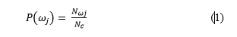
Then, for $N_{wj}$ in equation 1 that is the total of samples in w_{j} class, meanwhile for $N_{c}$ is the total of all samples for all data training. After getting the data training, giving for probability in class that uses equation 2 (Jackson,2020), the result of probability was shown in table 3.
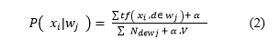
The description of the component in equation 2 that ;
- xi is data from data training in the sample,
- $\sum{tf\left( x_{i} , d∈ w_{j} \right)}$is frequent of parameters (wi) in wi of class,
- $\sum{ N_{dϵwj} }$is the total of data in wi of class,
- $α$ is the additional smoothing parameter and
- V is the size of data training.

Table 3 The Results of training data
 |  | Class
A | K | C | B | SB
 | -0.01 | -0.16 | -0.67 | -0.16
 | Duration
mean | 0 | 5.03048 | 5.6538 | 7.38389
std.dev | 0.23593 | 5.52328 | 3.79303 | 4.0725
weight | 0 | 23 | 102 | 24
precision | 1.53556 | 1.55356 | 1.55356 | 1.55536
 | Practice
1 Month | 1 | 23 | 89 | 18
6 Months | 1 | 1 | 14 | 8
> 1 years | 1 | 2 | 2 | 1
[total] | 3 | 26 | 105 | 27
 | Gender
L | 1 | 21 | 95 | 21
P | 1 | 4 | 9 | 5
[total] | 2 | 25 | 104 | 26
Location
Practice | 1 | 14 | 71 | 17
Admin | 1 | 11 | 33 | 9
[total] | 2 | 25 | 104 | 26
Ability of knowledge
1 | 1 | 8 | 3 | 1
2 | 1 | 15 | 53 | 3
3 | 1 | 3 | 47 | 13
4 | 1 | 1 | 3 | 11
[total] | 4 | 27 | 106 | 28
Honesty and integrity
1 | 1 | 9 | 3 | 1
2 | 1 | 16 | 50 | 1
3 | 1 | 1 | 47 | 14
4 | 1 | 1 | 6 | 12
[total] | 4 | 27 | 106 | 28
 | Initiative and creativity
1 | 1 | 14 | 6 | 1
2 | 1 | 9 | 58 | 2
3 | 1 | 3 | 41 | 21
4 | 1 | 1 | 1 | 4
[total] | 4 | 27 | 106 | 28
communication skills
1 | 1 | 19 | 3 | 1
2 | 1 | 5 | 47 | 2
3 | 1 | 2 | 49 | 16
4 | 1 | 1 | 7 | 9
[total] | 4 | 27 | 106 | 28
Responsibility and scrupulousness
1 | 1 | 8 | 2 | 1
2 | 1 | 13 | 45 | 3
3 | 1 | 5 | 57 | 18
4 | 1 | 1 | 2 | 6
[total] | 4 | 27 | 106 | 28
Cooperation skills
1 | 1 | 11 | 2 | 1
2 | 1 | 11 | 46 | 3
3 | 1 | 3 | 53 | 20
4 | 1 | 2 | 4 | 4
[total] | 4 | 27 | 105 | 28
Analysis and decision-making skills
1 | 1 | 12 | 1 | 1
2 | 1 | 13 | 65 | 4
3 | 1 | 1 | 37 | 21
4 | 1 | 1 | 3 | 2
[total] | 4 | 27 | 106 | 28
Coordination skills
1 | 1 | 14 | 5 | 1
2 | 1 | 10 | 45 | 3
3 | 1 | 2 | 52 | 19
4 | 1 | 1 | 4 | 5
[total] | 4 | 27 | 106 | 28
Task and action orientation
1 | 1 | 8 | 4 | 1
2 | 1 | 15 | 55 | 3
3 | 1 | 3 | 45 | 17
4 | 1 | 1 | 2 | 7
[total] | 4 | 27 | 106 | 28
Efficiency orientation
1 | 1 | 16 | 12 | 1
2 | 1 | 9 | 71 | 6
3 | 1 | 1 | 22 | 17
4 | 1 | 1 | 1 | 4
[total] | 4 | 27 | 106 | 28

The results of the calculation of the probability values of the main class using the naive Bayes algorithm are shown in table 3. The probability of class K (for bad grades) is 0.01 of the total class, class C (for average grades) is 0.16 of the total for the class, class B (for good grades) is 0.67 of the total for the class and class SB for very good. Grade) is 0.16 of the general class.
Furthermore, for each type of attribute in each type of class, the same is done, as z is worth 1, 1, 1, 3. In class C, the three types of attributes are worth 23, 1, 2, 16. In class B, the three types of attributes are worth 89,14,2,105. In class SB, the three types of attributes have a value of 18.8 1.27. Likewise, the same calculation is performed for the other 13 parameters, so that the evaluation value of the performance of the internship, students are based on the value with the highest probability.

Application
This app accesses online learning for students taking industrial hands-on courses in companies. Online learning provides an assessment of industry practice as shown in Figure 1. The rating is based on a combination of 14 parameters that weigh each parameter. Based on Table 1, the greatest weight in the evaluation for companies is the knowledge and cooperation that takes place at the beginning of the evaluation, as shown in Figure 2. More parameters in learning can be found online at all universities when taking the assessment. Evaluation management uses the naive Bayesian algorithm, as shown in Figure 2, to assign weights and order of highest priority to each evaluation based on the performance measurement in each organization.
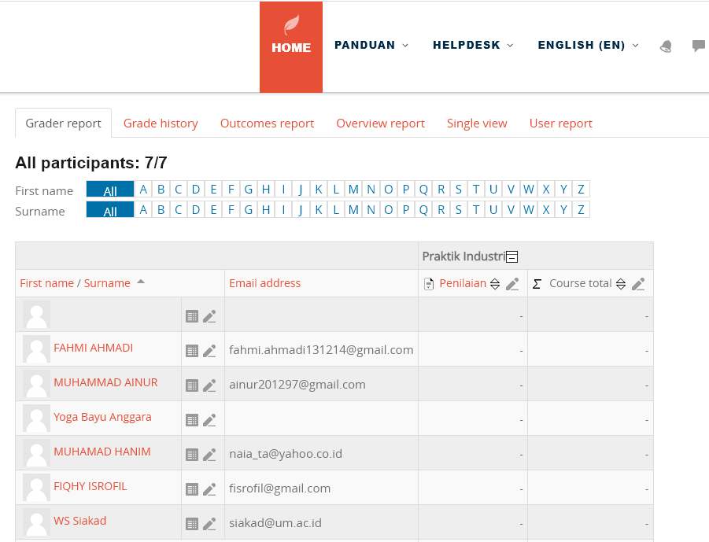

Figure 1. Online learning of industrial practices for the calculation of combined scores between the industry and the teachers
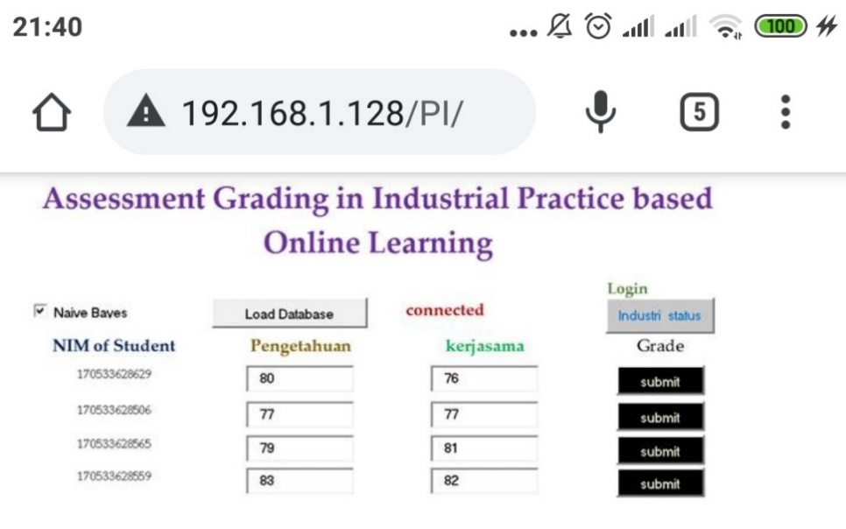

Figure 2. Completion of the values according to the most important weights of the evaluation
RESULT AND DISCUSSION
In this study, some of the data to be tested was tested
- Test of student assessment data Practice using naive Bayesian algorithm
- Test of declared value validation

Practical Student Assessment Data Testing
This test is used to test the accuracy of the training data according to equations 1 and 2, and the test procedure uses 10 times the CV. The test results are shown in Table 4.

Table 4. Evaluation of Student Practice Assessment Data Testing with Naïve Bayes Algorithm
Parameter | Data Training | 10 -fold CV
Time | 0 Seconds | 0 Seconds
Correctly | 92.63% | 82.632%
Incorrectly | 5.327% | 7.338%
Kappa | 0.89317 | 0.83489
Mean | 0.03431 | 0.04384
Root mean | 0.13073 | 0.16334
Relative | 13.937% | 19.736%
Root relative | 37.66377 | 47.05377
Correctly Classified | 140 | 133
Incorrectly Classified | 2 | 12
 | 0 0 0 0 | a = K | 0 0 0 0 | a = K
Confusion Matrix | 0 21 1 0 | b = C | 0 18 2 1 | b = C
Confusion Matrix | 0 1 95 4 | c = B | 0 2 95 4 | c = B
Confusion Matrix | 0 0 1 22 | d = SB | 0 0 2 24 | d = SB

Based on Table 4, the data analysis that the results of the evaluation data of the practitioners using the naive Bayes algorithm, where the value of the time required to build the model is 0 seconds, both in the results of the test the training data as in based on 10 times the resumes. Correctly classified instances are 94.63% in the training data test and 92.62% in the 10 CV test. The value of misclassified instances is 5.37% in the training data test and 7.38% in the 10 CV test. Kappa statistics mean absolute error, root means squared error, where the three evaluations are worth zero, so it can be said that the value of the error is very small. Successfully ranked instances contain 141 attributes of the successful ranking results in the training data test and 138 in the 10 CV test. Misclassified instances contain 8 attributes that are classified as incorrect in the training data test and 11 in the 10-time CV test. The results of this precision test are 93.63%.

Value validation test
The validation process is the same as when testing the algorithm, which took 10 times to test the validation. This test required 3 validators to verify the evaluation result. The validator application is shown in Figure 2. The validator comes from the industry or the company, teachers, and supervisors of the company in which the student is carrying out a practical branch.
The validator has verified all the evaluation results and has provided feedback that the format is valid or not. The result of the validation is shown in Table 5.
Table 5. The Result of the Validation
NIM | Company | University | supervisory program
170533628629 | Valid | Valid | Valid
170533628506 | Valid | Valid | Valid
170533628565 | Valid | Valid | Valid
170533628559 | Valid | Valid | No
170533628516 | No | Valid | Valid
170533628552 | Valid | Valid | Valid
170533628562 | No | No | Valid
170533628566 | Valid | Valid | No
170533628601 | Valid | Valid | No
170533628600 | Valid | Valid | No
Average | 100 | 60 | 60

Based on Table 3, the analysis is
1. The industry gave 10 students a valid status of 8
2. The teacher gave 10 students a valid status of 9.
3. The supervisor gave a valid status of 6 to 10 students.

However, all validators report the same valid status total but have had different numbers of students who did not give a valid grade. The result of the validation is that the mean is 73.33%.

CONCLUSION
Based on the testing in online learning that an application is made for the evaluation of students who work online in commercial practice. The assessment uses 14 staff performance parameters to assess students in conducting industrial internships for 1 month to 1 year. The 14 evaluation parameters have different weights depending on the parameter of each company. Built-in applications use machine learning algorithms to provide accurate scores based on weights for each parameter. The results showed that this application has a precise precision to evaluate the students during the industrial practice based on the performance parameters of the employees in any company or industry.

REFERENCES
Darmawan, M. S., Daeni, F., & Listiaji, P. (2020). The Use of Quizizz As An Online Assessment Application for Science Learning in The Pandemic Era. Unnes Science Education Journal, 9(3), 144-150.
Elzainy, A., El Sadik, A., & Al Abdulmonem, W. (2020). Experience of e-learning and online assessment during the COVID-19 pandemic at the College of Medicine, Qassim University. Journal of Taibah University Medical Sciences, 15(6), 456-462.
Divayana, D. G. H., Sappaile, B. I., Pujawan, I., Dibia, I. K., Artaningsih, L., Sundayana, I., & Sugiharni, G. A. D. (2017). An Evaluation of Instructional Process of Expert System Course Program by Using Mobile Technology-based CSE-UCLA Model. International Journal of Interactive Mobile Technologies, 11(6).
Hering, D., Moog, O., Sandin, L., & Verdonschot, P. F. (2004). Overview and application of the AQEM assessment system. Hydrobiologia, 516(1), 1-20.
Fee, K. (2013). Delivering e-learning. A complete strategy for design, application and assessment. Development and Learning in Organizations: An International Journal.
Alghamdi, M. I. (2020). Survey on Applications of Deep Learning and Machine Learning Techniques for Cyber Security. International Journal of Interactive Mobile Technologies, 14(16).
Jackson, C., Østerlund, C., Crowston, K., Harandi, M., Allen, S., Bahaadini, S., ... & Zevin, M. (2020). Teaching citizen scientists to categorize glitches using machine learning guided training. Computers in Human Behavior, 105, 106198.
Obermeyer, Z., & Emanuel, E. J. (2016). Predicting the future—big data, machine learning, and clinical medicine. The New England journal of medicine, 375(13), 1216.
Shakarami, A., Ghobaei-Arani, M., Masdari, M., & Hosseinzadeh, M. (2020). A survey on the computation offloading approaches in mobile edge/cloud computing environment: a stochastic-based perspective. Journal of Grid Computing, 18(4), 639-671.
Ristè, D., Da Silva, M. P., Ryan, C. A., Cross, A. W., Córcoles, A. D., Smolin, J. A., ... & Johnson, B. R. (2017). Demonstration of quantum advantage in machine learning. npj Quantum Information, 3(1), 1-5.
Wang, X. S., Ryoo, J. H. J., Bendle, N., & Kopalle, P. K. (2020). The role of machine learning analytics and metrics in retailing research. Journal of Retailing.
Chen, S., Webb, G. I., Liu, L., & Ma, X. (2020). A novel selective naïve Bayes algorithm. Knowledge-Based Systems, 192, 105361.
Kim, H. C., Park, J. H., Kim, D. W., & Lee, J. (2020). Multilabel naïve Bayes classification considering label dependence. Pattern Recognition Letters, 136, 279-285.
Wirawan, I. M. A., & Diarsa, I. W. B. (2018). Mobile-based Recommendation System for the Tour Package Using the Hybrid Method. iJIM, 12(8).

